STARTERS
GARLIC BREAD …… 3.25 add cheese and side of marinara ..… 5.75 add cheese, tomato and marinara ..… 6.95
MOZZARELLA STICKS Breaded, oven baked, served with our house marinara sauce ………………………………… 8.95
SAUSAGE AND PEPPERS Italian sausage, bell pepper, onion ……………………………………………..….……...… 8.95
WINGS Buffalo style, oven baked, served with blue cheese or ranch dressing …………………………………….……… 9.95
MEATBALLS Four meatballs topped with marinara, Romano ………………..…………………….……………………… 5.95
MAC AND CHEESE Dave’s recipe of a creamy blend of cheese, tossed with crumbled bacon ……………………….... 8.95
MEATBALL SLIDERS Hawaiian rolls, baked golden brown meatballs, mayo (order of 3) …………………………...… 6.95
CAPRESE Fresh tomato, Mozzarella and Romano cheese, basil, Extra Virgin Olive oil, drizzled with balsamic ……… 8.95

SALADS & SOUP
SHARON’S SALAD Romaine, kale, cucumber, tomato, carrot, feta, onion, cranberry, Sharon’s balsamic dressing …10.95
CAESAR SALAD (Cassano Style) Romaine, kale, romano, croutons, caesar dressing ……………………………….. 8.95
MINI CAESAR SALAD Romaine, kale, romano, croutons, caesar dressing …………………………………………….. 4.95
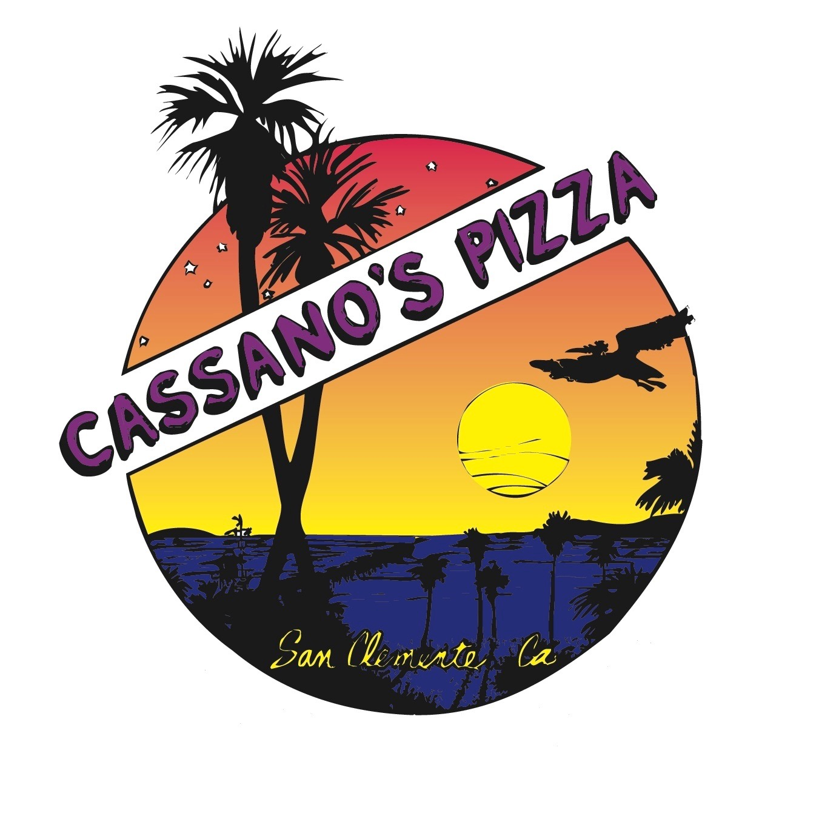
CUCUMBER SALAD tomato, carrots, spinach, feta, sunflower seeds, romano, Sharon’s balsamic dressing………... 10.95
CAPRESE SALAD Tomato, Mozzarella, Romano, Basil, Extra Virgin Olive Oil and balsamic served over Arugula……….…… 10.95
KALE AND QUINOA Organic Quinoa, kale, cranberry, carrots, cucumber, artichoke, feta cheese, sunflower seeds
tossed in a red wine vinaigrette ………………………………………………………………………………..…………….… 9.95
DAVE’S SALAD Romaine, kale, red onion, green pepper, olives, pepperoncini, mushroom, carrot, cucumber,
Tomato, Romano cheese, your choice of dressing ………………..…..…………..………………………………………..… 9.95
ARUGULA SALAD nitrate free slivered pepperoni, tomato, grapes, red onion, shaved parmesan,
tossed in a red wine vinaigrette dressing …………………………………………….…………………………………………. 9.95
DINNER SALAD Romaine, mixed organic greens, tomato, cucumber, pepperoncini ……………………………..……… 4.95
MINESTRONE SOUP BOWL (Vegetarian) Vegetables, beans, pasta, savory vegetable stock …………………..….… 5.95
Add: Chicken … 3.75 Add: Quinoa… 1.50 Additional side of dressing .75
Dressings: Sharon’s balsamic made in house (no sugar added), Blue Cheese, Ranch, Italian

PIZZA
CHEESE PIZZA LARGE 16”…... 15.95 MED 14”.…...13.95 PERSONAL 10”.…… 7.95
BUILD YOUR OWN Choose any 3 toppings LARGE 16”.…. 19.95 MED 14”..…...18.50 PERSONAL 10”.…… 9.95
GLUTEN FREE 14” CRUST ADDITIONAL …..………………………..…..……… 2.50
CAULIFLOWER 10” GLUTEN FREE LOW CARB ADDITIONAL…….…...…….. 2.50

TOPPINGS: Each Topping ………Med and Large 2.00..….……..Personal 1.00
artichoke | arugula | bacon | basil | bell pepper | black olive
Canadian bacon | *chicken | extra cheese | feta | fresh garlic | jalapeno
kale | meatball | mushroom | pepperoncini | *pepperoni | pineapple
sausage | spinach | tomato | red onion | white onion

* pepperoni is uncured, no nitrate or nitrite added, no preservatives
*chicken is hormone and antibiotic free

HOUSE PIZZAS 16” 10”
WHITE PIZZA Creamy ricotta, imported Romano cheese sauce, mozzarella, basil ……………………… 18.95 11.95
BARBECUE HAWAIIAN Tangy barbecue sauce, Canadian bacon, pineapple, red onion …………….… 18.95 11.95
PEANUT BUTTER AND BACON Creamy peanut butter, mozzarella, topped with crumbled bacon …… 18.95 11.95
BARBECUE CHICKEN Barbecue sauce, mozzarella, red onion, tender breast of chicken ……………… 18.95 11.95
ST. PATTY’S Corned beef, Richie’s mustard sauce, onion, sauerkraut, mozzarella ……………………… 18.95 11.95
MARGHERITA PIZZA Tomato, basil, garlic, light sauce, light mozzarella ………………………………… 18.95 11.95
VERY VEGGIE Light sauce, garlic, kale, spinach, tomato, mushroom, red onion, light mozzarella……. 18.95 n/a
GLUTEN FREE 14” CRUST ADDITIONAL …..………………………..…..….…… 2.50
CAULIFLOWER 10” GLUTEN FREE LOW CARB ADDITIONAL…….………….. 2.50

CALZONE: (PLEASE ALLOW 20 MINUTES)
Oven baked, filled with a blend of ricotta, romano, mozzarella, and house marinara. Served with a side of house marinara sauce and pepperoncins.................................................................................................................................................10.95
Additional toppings (limit is 3 toppings)…………………………………………………………………………………… .75 each

SANDWICHES.....served with a side of salad and pepperoncini
MEATBALL Five large oven baked meatballs smothered with a blend of cheese, marinara on an Italian roll …...…. 10.95
CHICKEN PARMIGIANA Breaded Chicken, marinara , mozzarella, Romano on Italian roll …..…………..………..… 10.95
CORNED BEEF Richie’s mustard sauce, corned beef, sauerkraut, onions, served on Italian roll…………………….. 10.95
CAPRESE SANDWICH Fresh tomato, mozzarella & basil drizzled with O/V & served on toasted Italian roll .…….. 10.95

PASTA AND ITALIAN SPECIALTIES…..Served with garlic bread
SPAGHETTI Our family recipe marinara sauce, imported cheese ………… 9.95 add meatballs or sausage …..….… 3.00
LASAGNA Layers of spinach noodles, cheeses, marinara ………..……… 12.95 add sausage or vegetables .……… 2.00
RAVIOLI Pasta pockets filled with a delicate blend of cheese, topped with artichoke hearts, marinara ...…….…..……11.95
TORTELLINI Sausage, beef, creamy rose sauce, topped with mozzarella and bacon……… ………………………….. 12.95
SAUSAGE AND PEPPERS OVER PENNE Italian sausage, roasted bell pepper, onions, marinara ……………..……12.95
FETTUCCINE ALFREDO White creamy cheese sauce ………………..… 12.20 add chicken and mushroom ….…… 3.75
PALMINI PASTA Hearts of Palm served linguini style w/marinara sauce & garlic bread ……………………….………. 12.95
PALMINI TIFF’S STYLE Palmini, marinara, arugula, feta, fresh garlic & artichoke hearts………………………………. 14.95
CHICKEN PARMIGIANA Breaded chicken breast layered w/ marinara & melted mozzarella over penne pasta …...12.95
Side of meatballs 5.95...............Side of marinara 2.50………….Sub Palmini for pasta 2.95

**Add any toppings to pasta at standard menu price** **PALMINI is a veggie/low carb alternative to pasta**

DESSERT
SHARON’S CHEESECAKE Graham cracker crust, creamy cheese filling, a family favorite made fresh in house …… 6.95
WHOLE CHEESECAKE (minimum 48 hour notice) …………………………….…………………………………………… 35.00
CANNOLI Pastry tube filled with delicate cream and chocolate bits ……….… 1.95 each Basket of 4 ..……..….. 6.95

SOFT DRINKS
Pepsi, Diet Pepsi, Dr Pepper, Sierra Mist, Pink Lemonade, Root Beer, Iced Tea, Sparkling Water …………….………. 2.25

